Össur Braces
Unloader One X
The Unloader One X features the Össur 3-Point Leverage System. This patented system is clinically proven to improve mobility by providing pain relief from unicompartmental knee OA or degenerative meniscal tears.
Key Features
Comfort
• Breathable and skin friendly soft goods
• Contours easily to leg shape
• 100 grams lighter than Unloader One SD
• Optimised calf strap design for less migration
• Over-moulded straps resulting in gradual unloading effect
Easy to use
• Machine washable for easy cleaning
• Integrated Smartdosing system for easy self-dosing of pain relief
• Redesigned Quick-Fit buckles with lever arms for easy closure, even by users with limited strength
• Straps adjustable anteriorly
• Improved popliteal pad adjustment
Aesthetics
• Stylish, low-profile frame with soft edges
• Thinner, low profile straps
• New ‘forged iron’ colour design

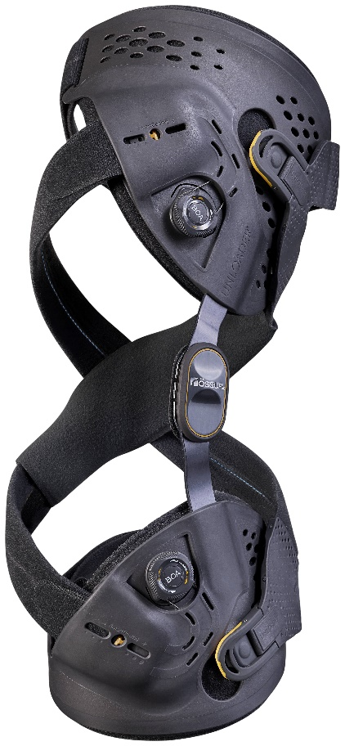
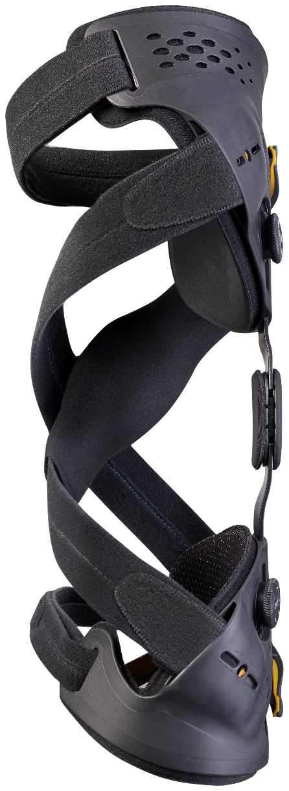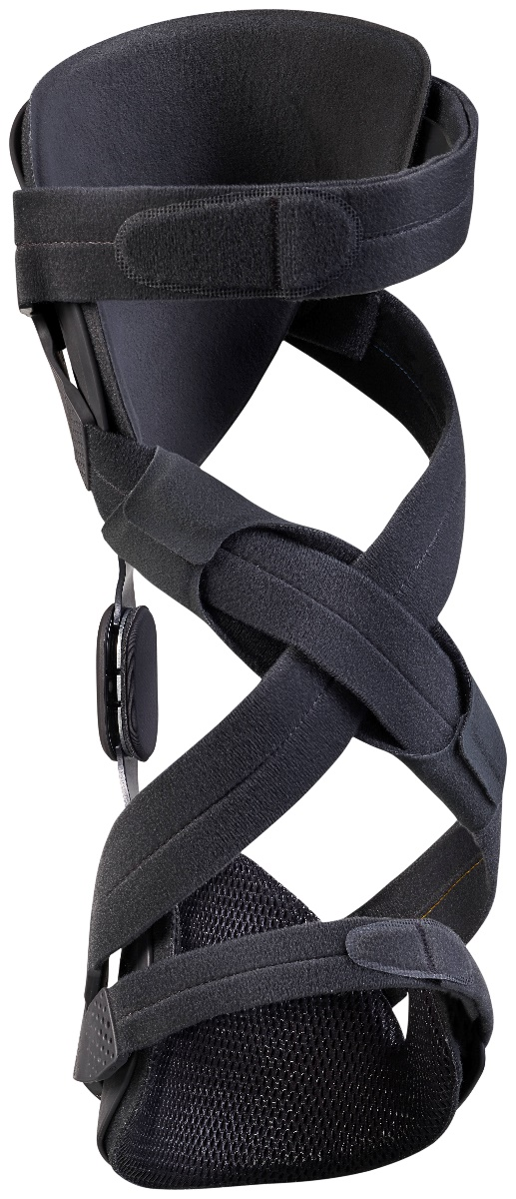

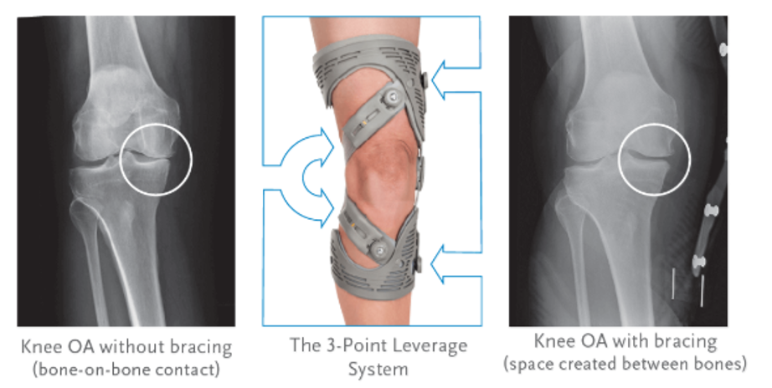
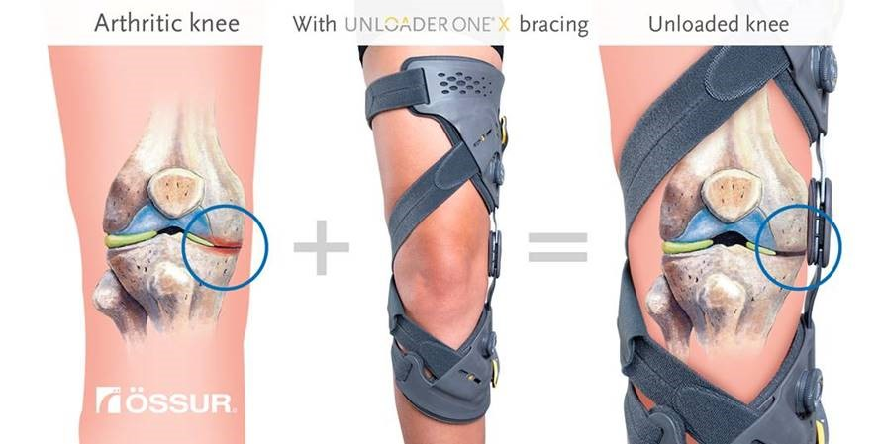

CTi OTS Knee Brace
WHAT IS THE CTI?
Introduced thirty years ago to stabilise and protect ligaments and cartilage, the tried and tested CTi design has evolved over time. The central concept, however, remains the same – a static support system consisting of a rigid frame and non-elastic straps.
The CTi® OTS substitutes elements of the rigid CTi® frame with flexible subshells, providing adjustability and an excellent out-of-the-box fit while maintaining the level of support and protection that you would expect from a CTi® knee brace.
WHAT ARE THE ADVANTAGES OF THE CTI?
With the CTi, the rigid, carbon composite frame supports the shinbone, providing the brace-to-bone contact that’s crucial for maximum stabilisation of the knee joint.
In comparison, non-rigid braces tend to fail under significant stress and braces that substitute soft tissue containment for brace-to-bone contact usually have increased migration problems (i.e. the brace moves during your activity).
CTi’s claim to fame and superiority over alternative dynamic systems is borne out by thousands of satisfied sports people, as well as top surgeons and associated knee specialists. Here are some of the key design features your knees can rely on.

- Total Support System™ provides support for ACL, MCL, LCL rotary and combined instabilities
- An optional PCL kit can be added to provide support following injury to the posterior cruciate ligament
- Hand-laminated, pre-preg carbon fibre construction provides true rigid support
- Frame shape is low-profile and contours to the leg, making it suitable for a variety of physical activities
- Anatomically correct Accutrac™ hinges with extension stops track the natural movement of the knee
- Sensil® breathable lining increases comfort and reduces slippage
- Flexible lower cuff provides increased protection against rotational forces
- Constructed from non-corroding materials, enabling use for water sports
- Available in 5 sizes, left and right

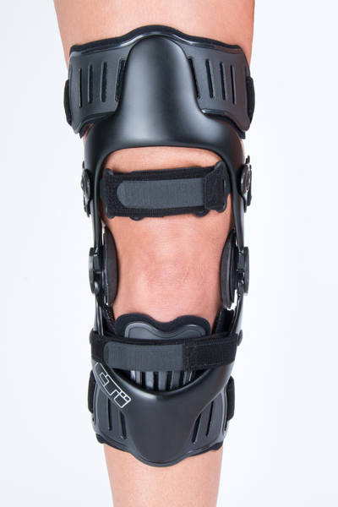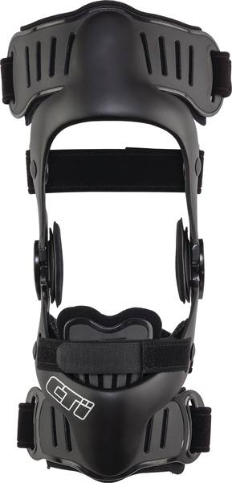

Custom CTi Knee Brace
